Rock Paper Scissors Game
- Need to create two users with name:
First player name: play1
Second player name: play2

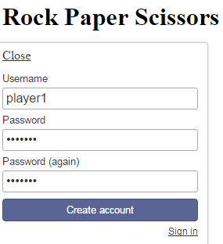
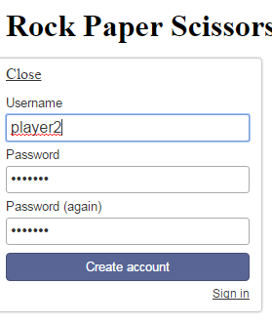

- Start game: Each player need to select symbol(Rock or Paper or Scissors)

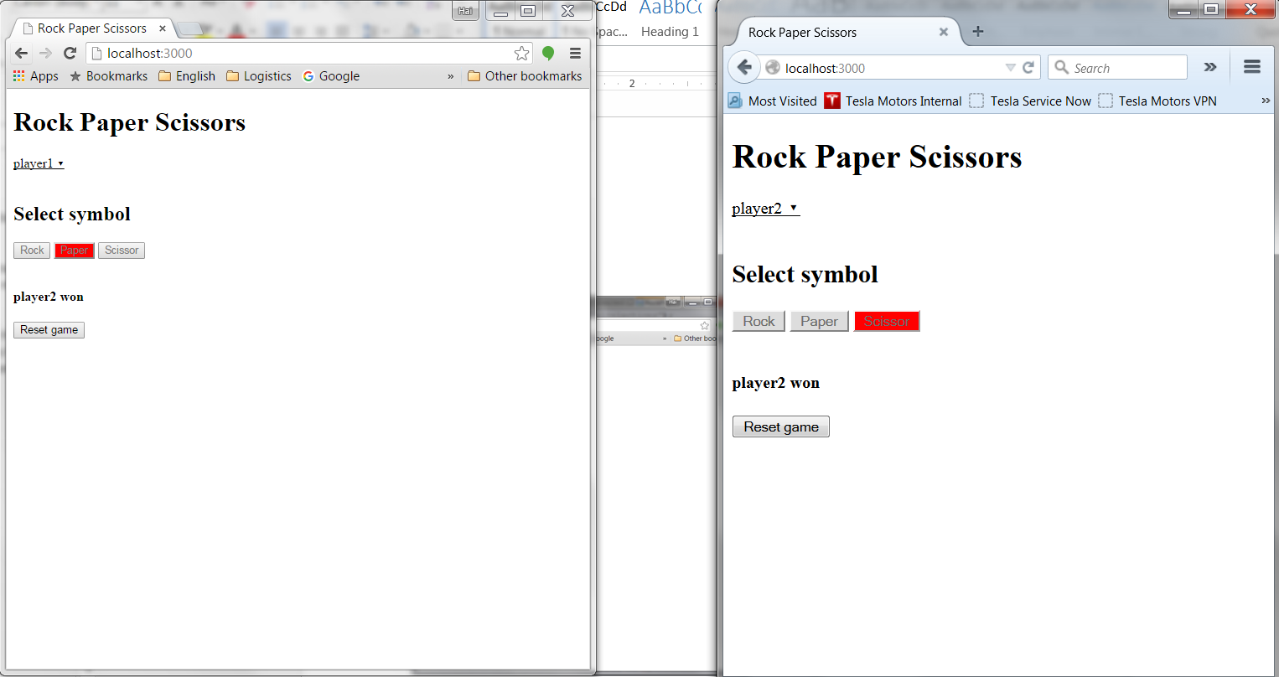

When game is over, user can click button “Reset game” to start

